1st question
Is the Result Service GET API in the architecture design doc supposed to be GET /api/results/student/:studentId instead of GET /api/results/:studentId

2nd question
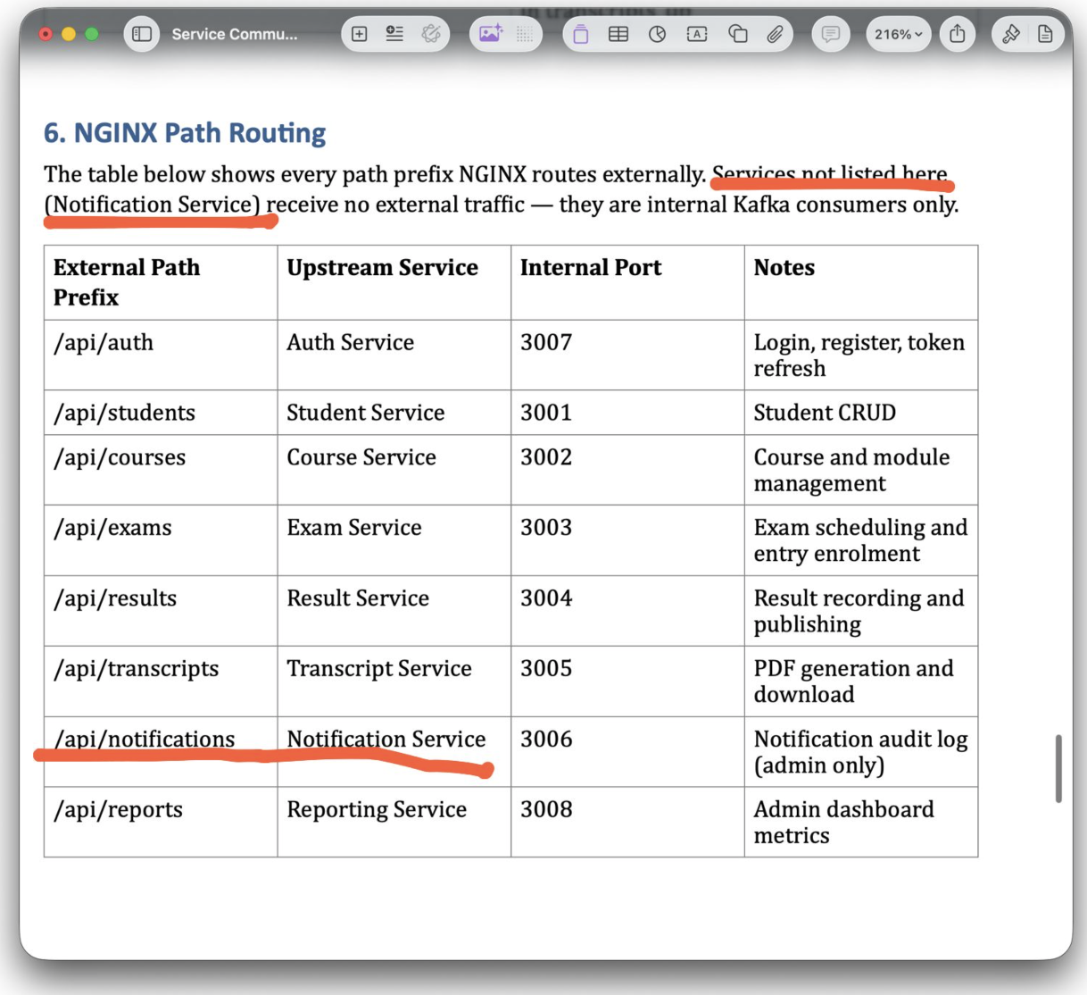
Noticed that It says services not listed here (notification service) and has notification service again in the table
can you check this happenning or not?

3rd question
What if add a component-level architecture diagram to the Architecture Design Document
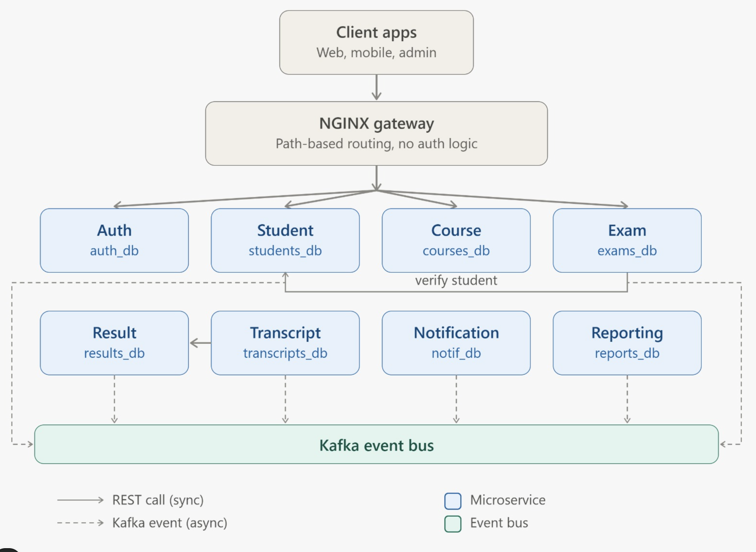
can you check possibility to do this?

5th question
Don't we need to mention that certain end points need to be restricted by the role, for an example POST /api/exams should be admin only
6th question
Should we add a standard error response schema to the API endpoint docs? Right now, we mention status codes like 400, but we don't show what the actual error response body will look like.

7th question
can't we add this under Risks and Mitigations?
API Versioning / Backward Compatibility

Risk: Consumer services (e.g., the Exam Service relying on the Student Service's API, or the Transcript, Notification, and Reporting Services consuming Kafka events) can break if a producer changes the API response or event payload. Since there is no compile-time validation between services, changes such as renaming or removing a field may only be discovered at runtime.

Mitigation: This is not implemented in the current prototype. In a production system, API versioning (e.g., /api/v1/...), schema versioning for events, and consumer-driven contract testing (e.g., Pact) would be used to detect breaking changes before deployment.

